Mapping Youth Urban Projects
A template for the Youth Mayors website

 | 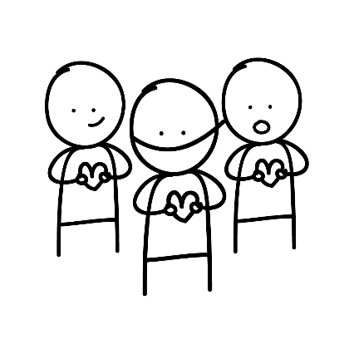
Name |  | Project name or title
Here you write:

- The name of the project
- Location of the project (city, country)
- Your/your team member’s name(s) and affiliated school/organization
- A 75-100 word summary of the project: What is the aim/goal and how will it be achieved?
- Motivation: (75 word summary) Why have you started this project?
- Which UN Sustainable Development Goals can be linked to (see below)
- 3-5 key words (e.g.: “Poverty, Children, Discrimination, Education”) to tag your project

 | 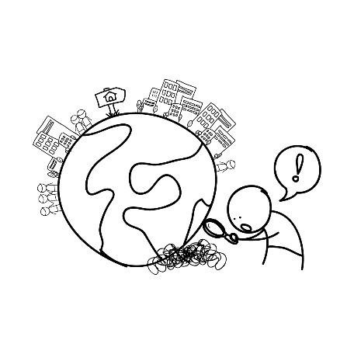
Step 1 |  | Identifying challenges
Here you write:

- What challenge or need is your project meant to offer a solution to?
- How did you discover and identify this particular challenge or need?
- What inside knowledge did you gain to ensure you know what you need to know to make this project meaningful?

 | 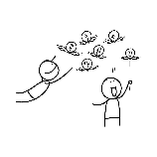
Step 2 |  | Gathering ideas
Here you write:

- The steps you took to turn your identified challenge into ideas for a project.
- How did you collect your ideas? Who took part in this process?
- How did you involve the local community/participants in collecting ideas?

Step 3 |  | Developing a project
Here you write:

- How you developed your project
- What was needed to ensure the project would be a success? (Local involvement, funding, engaging with different stakeholders, partnerships, collaboration, etc.)

 | 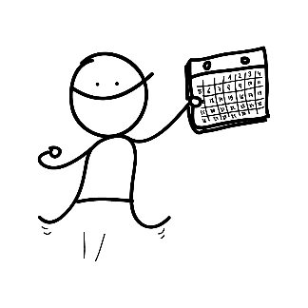
Step 4 |  | Action!
This is perhaps the most important Step in the entire process. Here you write:

- How you carried out the project. What you actually did.
- Who was involved, how long it took, what was the cost, how did you secure funding, etc.
- Add pictures or (preferably) a short video (very short: 1- 2 minutes) of the project. This will allow the viewer to really understand what the project is about, and what you did.

Step 5 |  | Share your learning
Here you write:

- Your personal evaluation of the project: What went well? Why? What went wrong or could have gone better? Why?
- Your reflection on key lessons learnt: Based on your own successes and mistakes while designing and implementing the project, if someone else wants to do a similar project, what should they keep in mind?

